# Eugene’s Composition 3 ideas:

# max. 1-paragraph description of the piece you’re planning

* My piece, working title *My Digital Life*, will be a commentary on how technology has negatively affected us during the COVID-19 pandemic. Although technology has enabled us to continue our professional and personal lives, it has also forced us to look towards it for almost all forms of engagement with the outside world (interaction, entertainment, news, etc.). In my opinion, this single fixation is very dangerous and has accelerated an already existing trend of looking towards technology for fulfillment.

# scans/photos/PDFs of any visual material or sketches you would have shared today

* Here’s a screenshot of the headline I read last week:
* 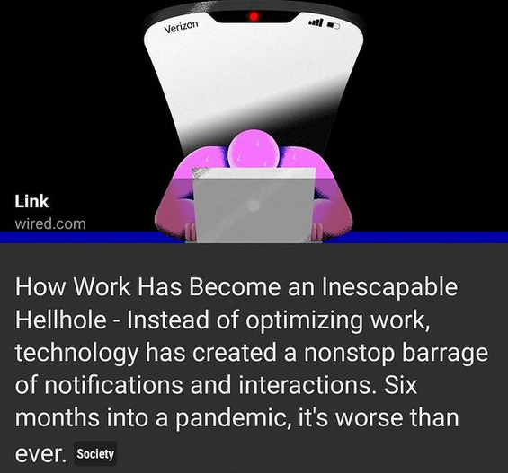
* Along with some excerpts from *The Question Concerning Technology* by Martin Heidegger.
* 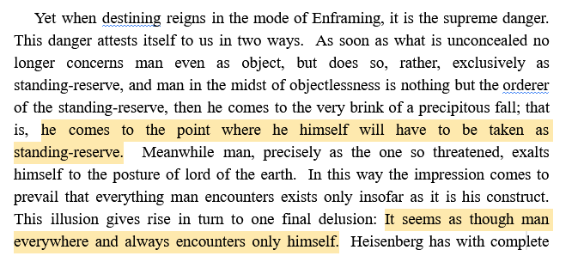
* 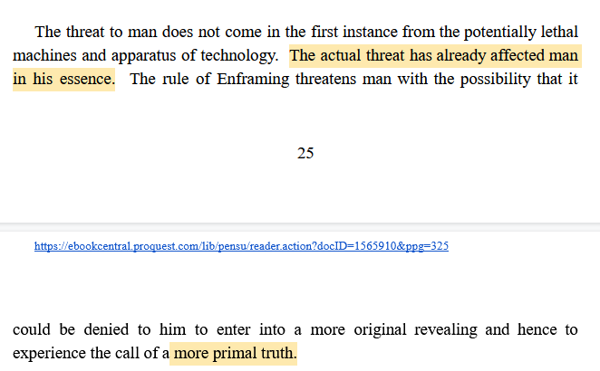
* 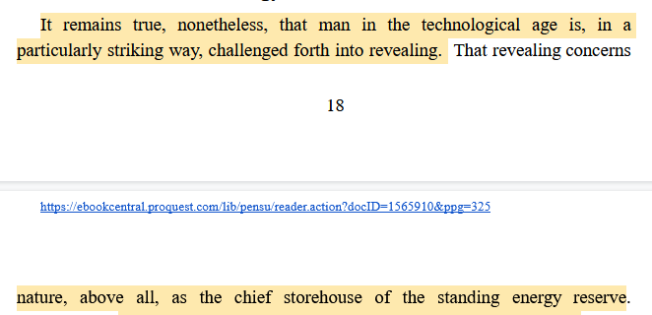
* 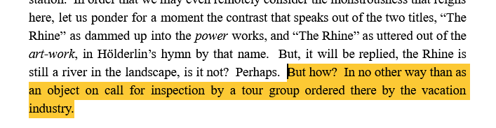
* 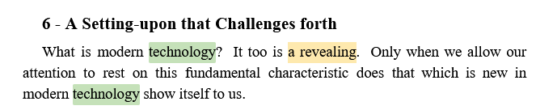
* 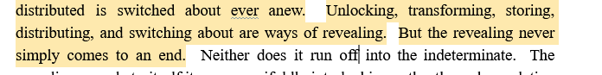
* To me, these are saying “technology has allowed man to shape the world and its resources into extensions of himself – however, this has led us down a path where we rely too much on technology to reveal the purpose of things for us, molding our worldview to be beholden to technology”.
* There are also many excerpts on how technology has conditioned man into itself – to constantly seek optimization, the best possible thing/process for its own sake (grind culture) for its own sake – another dangerous byproduct of our reliance on technology.

# what will the nature of your score be?

* The performed aspect will be through the performer’s phone – depending on the feasibility, I want to have drones or sounds generated via Supercollider whose pitches and amplitudes are intensified based on the frequency and length of notifications received on the user’s phone.
* The fixed media/tape portion will be a backing track of spoken-word technology statistics and thoughts, along with COVID-19 related updates to reflect the enveloping nature of the pandemic news cycle.
* Since the piece is intended to dynamic, the score will be pretty freeform. It will include the instructions for performance, along with some blurbs about technology, especially during the pandemic, that will help the performer get in the right mindset for performance.
* “Turn your phone’s notification volume to max and leave it on a desk with the microphone pointing at it”.
* If I can figure out how to do text-to-speech with android notifications, I will instruct the performer to download the app as well.
* “make whatever sound that you feel – express your frustration or reaction to what is going on around you during the performance as you see fit.”
* I liked the idea you suggested last week about having the audience participate (sending texts, etc.).
* Another way to help the performer get into the right mindset would be to have them look at their screen time on their phone/computer – I know that when I look at it I do not like what I see.

# - what are your next steps in completing this (goals for next week).

* Finishing supercollider code for live input
* More research into Android programming – with only 2/3 weeks left in the semester, how realistic is it to learn Android well enough to write the service I’m envisioning?
* Find better-suited excerpts from *The Question Concerning Technology***.**